**1、K8s快速入门**

**1）简介**

kubernetes简称k8s。是用于自动部署，扩展和管理容器化应用程序的开源系统。  
中文官网：https://kubernetes.io/Zh/  
中文社区：https://www.kubernetes.org.cn/  
官方文档：https://kubernetes.io/zh/docs/home/  
社区文档：https://docs.kubernetes.org.cn/

部署方式的进化：

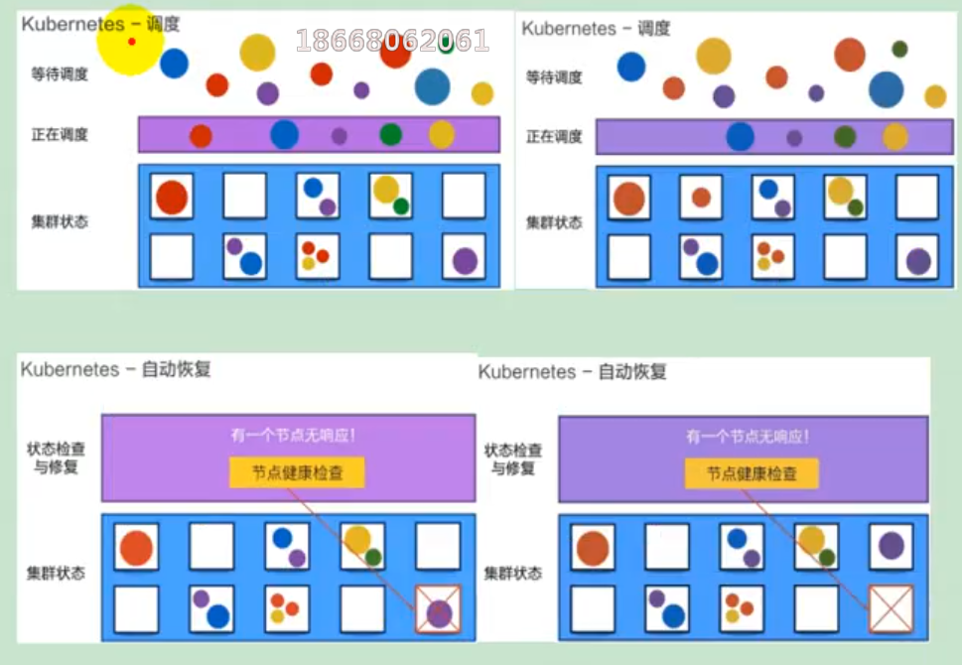

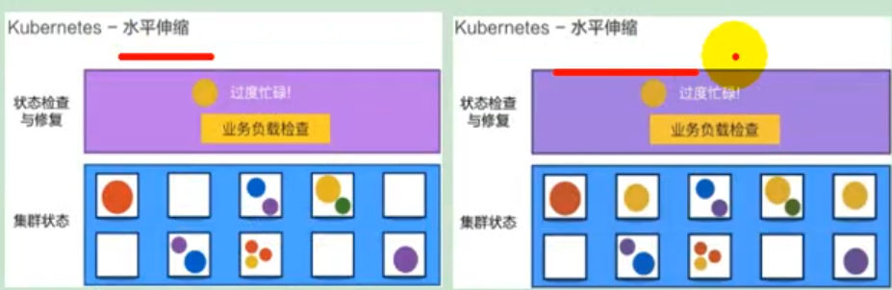

**2）架构**

**（1）整体主从方式**

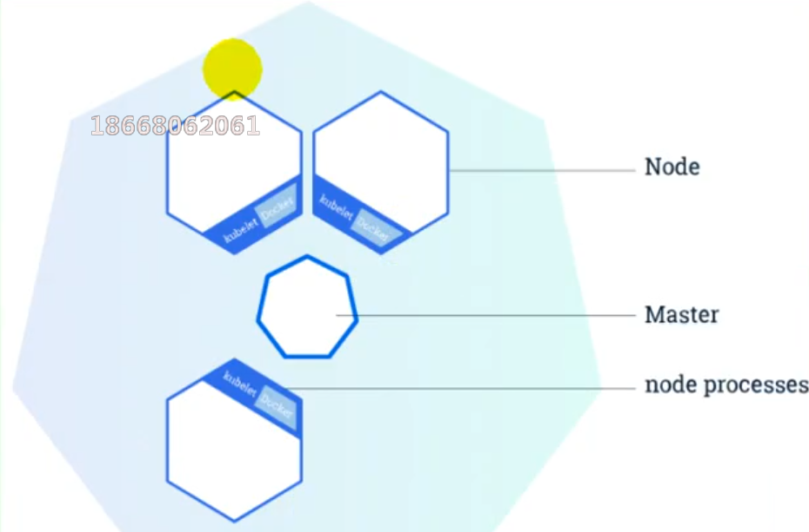

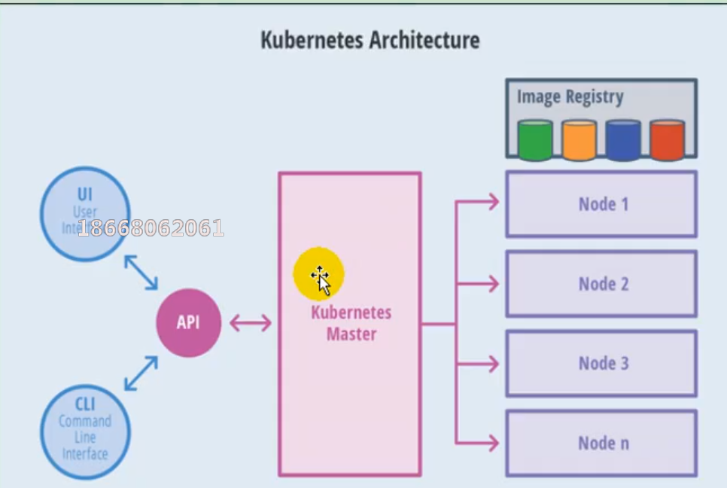

**（2）master节点架构**

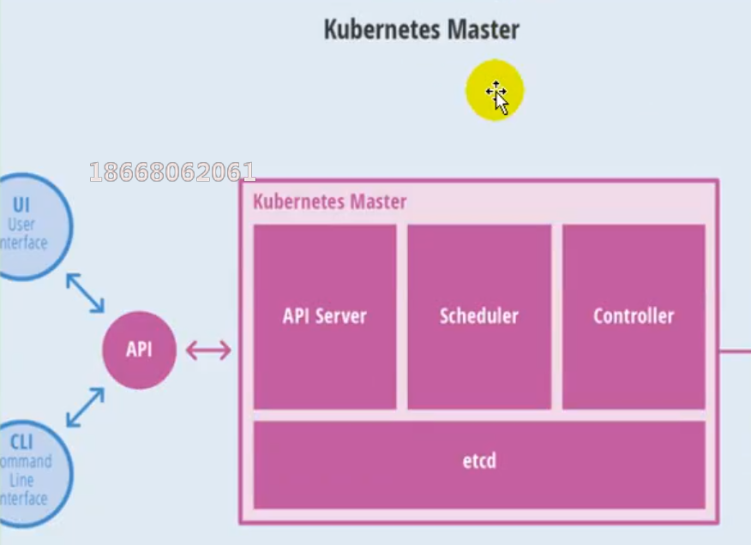

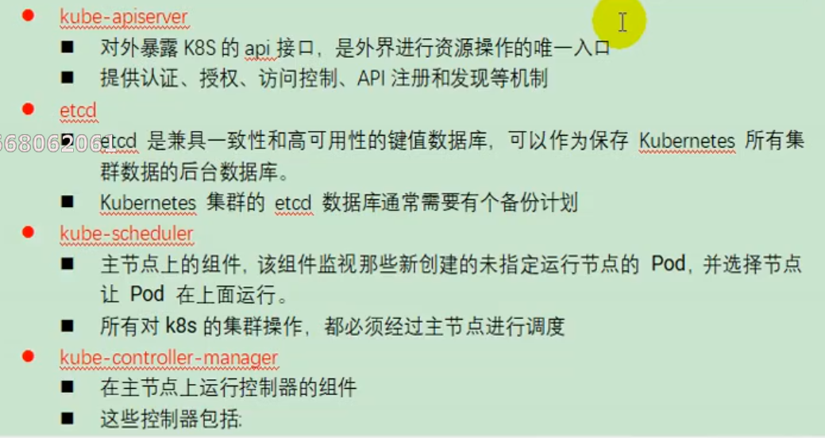

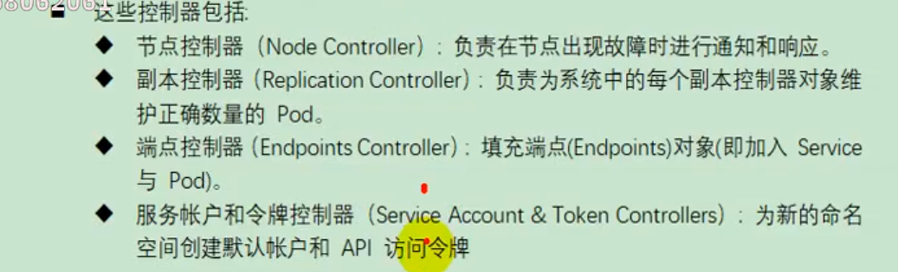

**（3）Node节点架构**

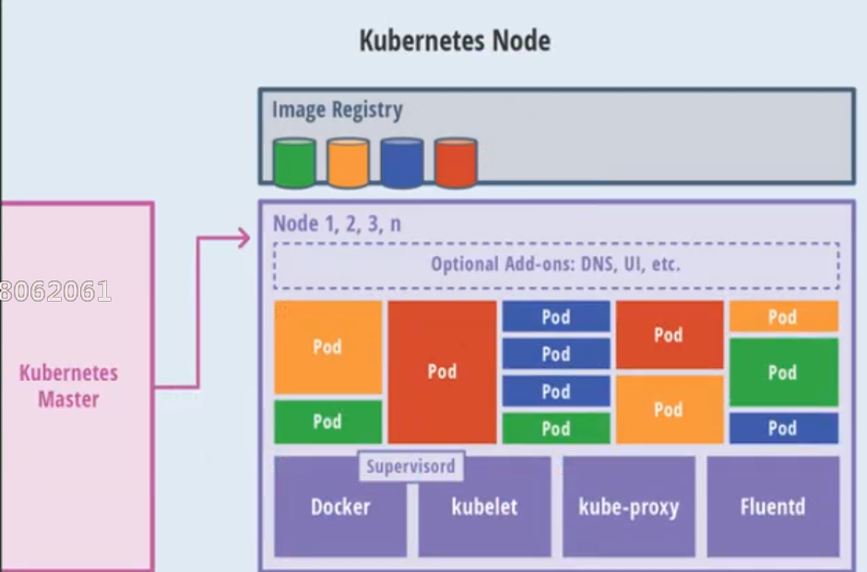

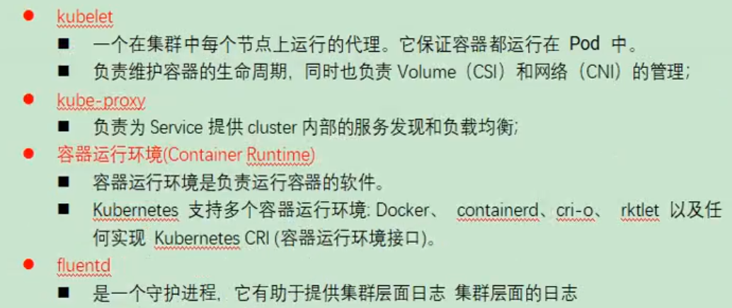

**3）概念**

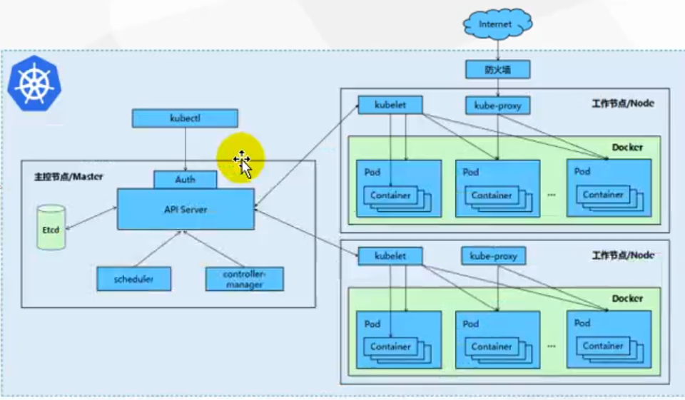

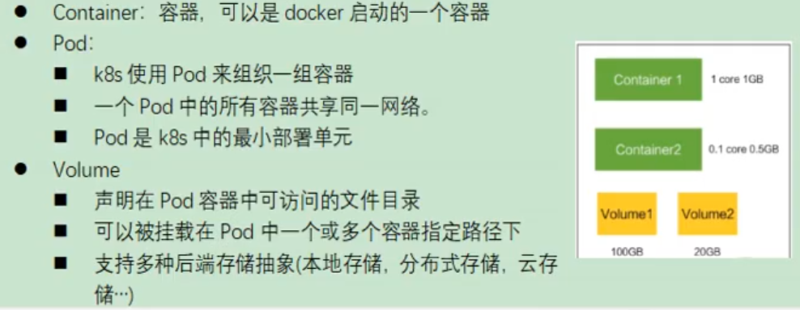

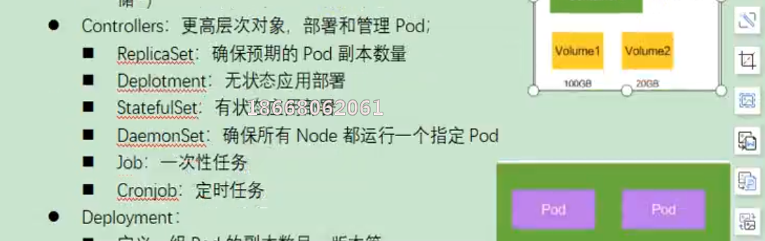

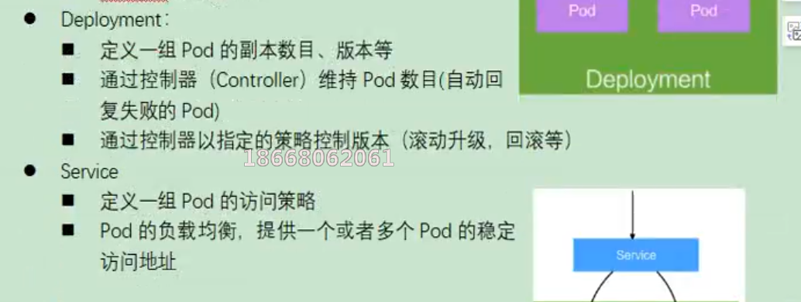

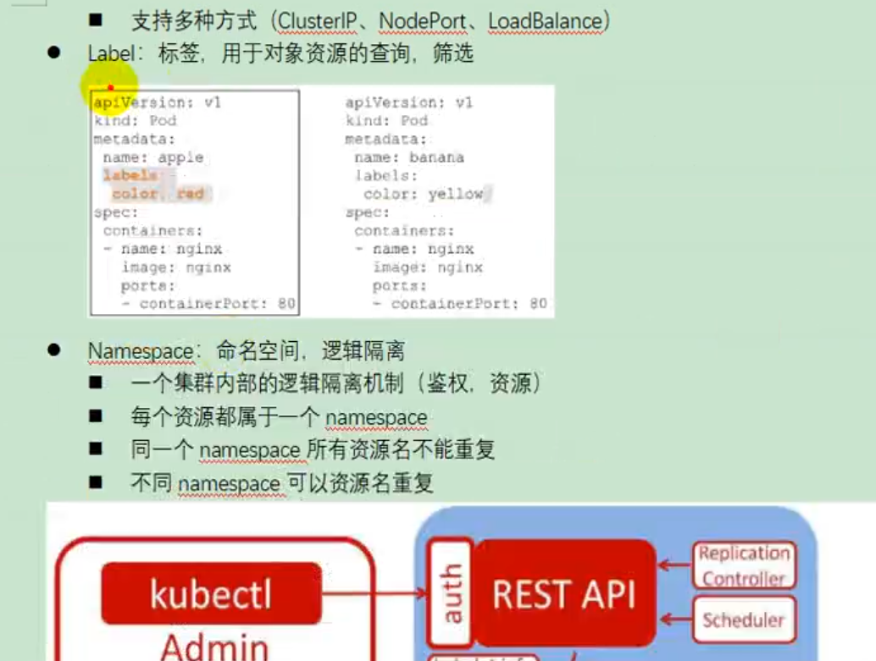

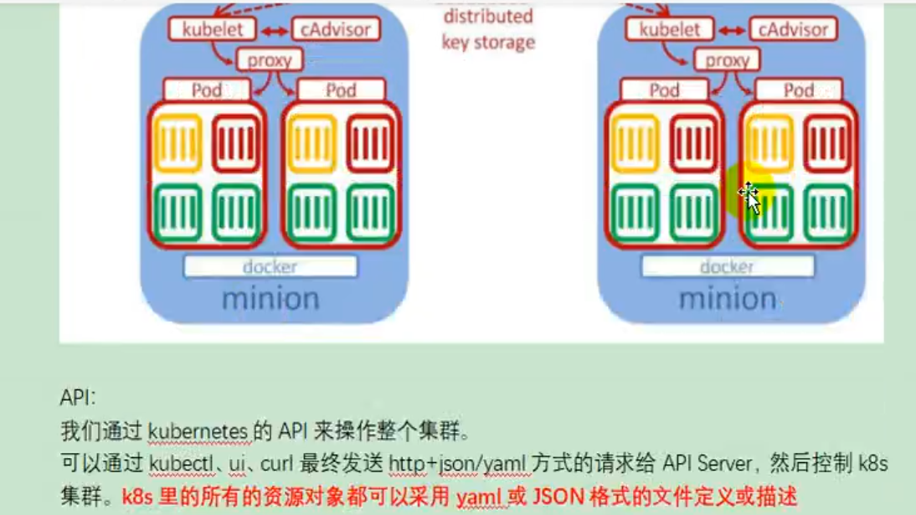

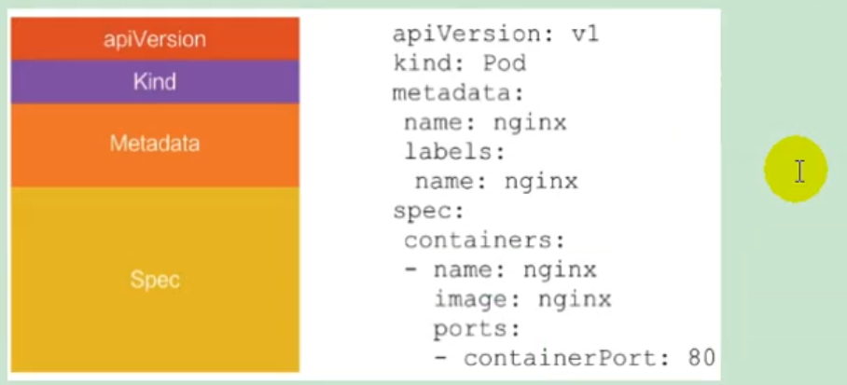

**4）快速体验**

**（1）安装minikube**

https://github.com/kubernetes/minikube/releases  
下载minikuber-windows-amd64.exe 改名为minikube.exe  
打开virtualBox，打开cmd  
运行  
minikube start --vm-driver=virtualbox --registry-mirror=https://registry.docker-cn.com  
等待20分钟即可。

**（2）体验nginx部署升级**

1. 提交一个nginx deployment  
   kubectl apply -f https://k8s.io/examples/application/deployment.yaml
2. 升级 nginx deployment  
   kubectl apply -f https://k8s.io/examples/application/deployment-update.yaml
3. 扩容 nginx deployment

**2、K8s集群安装**

**1）kubeadm**

kubeadm是官方社区推出的一个用于快速部署kuberneters集群的工具。  
这个工具能通过两条指令完成一个kuberneters集群的部署

创建一个master节点

$ kuberneters init

将一个node节点加入到当前集群中

$ kubeadm join <Master节点的IP和端口>

**2）前置要求**

一台或多台机器，操作系统Centos7.x-86_x64  
硬件配置：2GB或更多RAM，2个CPU或更多CPU，硬盘30GB或更多  
集群中所有的机器之间网络互通  
可以访问外网，需要拉取镜像  
禁止Swap分区

**3）部署步骤**

1. 在所有的节点上安装Docker和kubeadm
2. 不是Kubernetes Master
3. 部署容器网络插件
4. 部署Kubernetes Node，将节点加入Kubernetes集群中
5. 部署DashBoard web页面，可视化查看Kubernetes资源

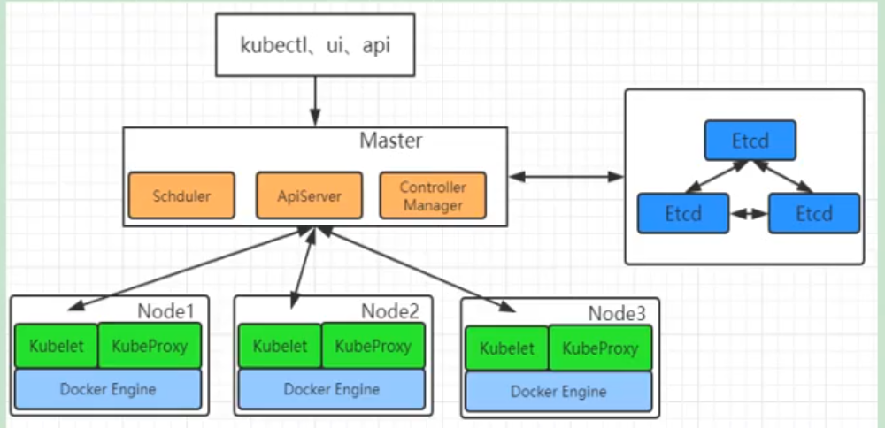

**4）环境准备**

**（1）准备工作**

* 我们可以使用vagrant快速创建三个虚拟机。虚拟机启动前先设置virtualbox的主机网络。现在全部统一为192.168.56.1，以后所有虚拟机都是56.x的ip地址。

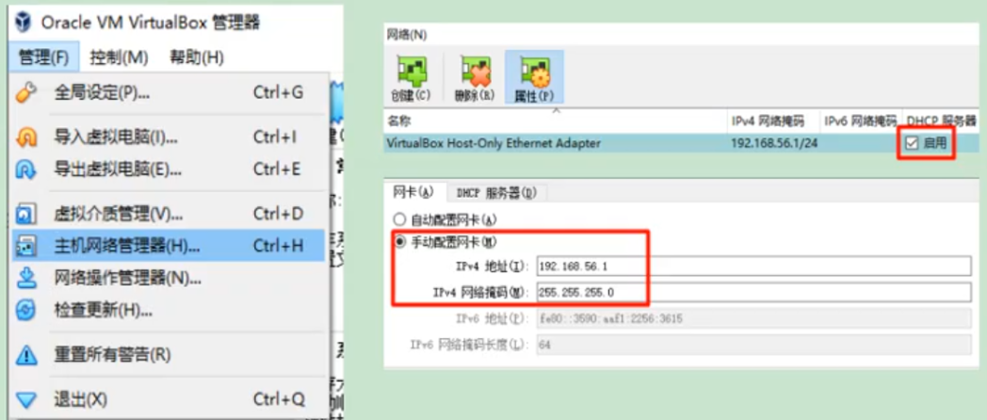

* 在全局设定中，找到一个空间比较大的磁盘用用来存放镜像。

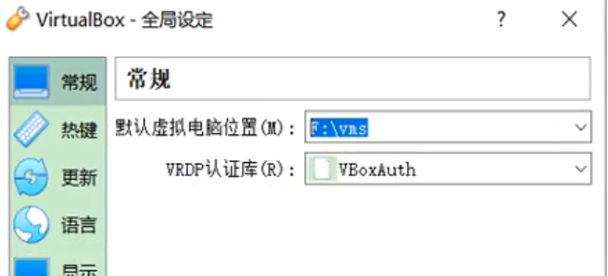

**（2）启动三个虚拟机**

* 使用我们提供的vagrant文件，复制到非中文无空格目录下，运行vagrant up启动三个虚拟机。其实vagrant完全可以一键部署全部K8s集群  
  https://github.com/rootsongjc/kubernetes-vagrant-centos-cluster  
  http://github.com/davidkbainbridge/k8s-playground

下面是vagrantfile，使用它来创建三个虚拟机，分别为k8s-node1，k8s-node2和k8s-node3.

Vagrant.configure("2") do |config|

(1..3).each do |i|

config.vm.define "k8s-node#{i}" do |node|

# 设置虚拟机的Box

node.vm.box = "centos/7"

# 设置虚拟机的主机名

node.vm.hostname="k8s-node#{i}"

# 设置虚拟机的IP

node.vm.network "private_network", ip: "192.168.56.#{99+i}", netmask: "255.255.255.0"

# 设置主机与虚拟机的共享目录

# node.vm.synced_folder "~/Documents/vagrant/share", "/home/vagrant/share"

# VirtaulBox相关配置

node.vm.provider "virtualbox" do |v|

# 设置虚拟机的名称

v.name = "k8s-node#{i}"

# 设置虚拟机的内存大小

v.memory = 4096

# 设置虚拟机的CPU个数

v.cpus = 4

end

end

end

end

* 进入到三个虚拟机，开启root的密码访问权限

Vagrant ssh xxx进入到系统后

su root 密码为vagrant

vi /etc/ssh/sshd_config

修改

PermitRootLogin yes

PasswordAuthentication yes

所有的虚拟机设为4核4G

关于在"网络地址转换"的连接方式下，三个节点的eth0，IP地址相同的问题。

**问题描述：**查看k8s-node1的路由表：

[root@k8s-node1 ~]# ip route show

default via 10.0.2.2 dev eth0 proto dhcp metric 100

10.0.2.0/24 dev eth0 proto kernel scope link src 10.0.2.15 metric 100

192.168.56.0/24 dev eth1 proto kernel scope link src 192.168.56.100 metric 101

[root@k8s-node1 ~

能够看到路由表中记录的是，通过端口eth0进行数据包的收发。

分别查看k8s-node1，k8s-node2和k8s-node3的eth0所绑定的IP地址，发现它们都是相同的，全都是10.0.2.15，这些地址是供kubernetes集群通信用的，区别于eth1上的IP地址，是通远程管理使用的。

[root@k8s-node1 ~]# ip addr

...

2: eth0: <BROADCAST,MULTICAST,UP,LOWER_UP> mtu 1500 qdisc pfifo_fast state UP group default qlen 1000

link/ether 52:54:00:8a:fe:e6 brd ff:ff:ff:ff:ff:ff

inet 10.0.2.15/24 brd 10.0.2.255 scope global noprefixroute dynamic eth0

valid_lft 84418sec preferred_lft 84418sec

inet6 fe80::5054:ff:fe8a:fee6/64 scope link

valid_lft forever preferred_lft forever

3: eth1: <BROADCAST,MULTICAST,UP,LOWER_UP> mtu 1500 qdisc pfifo_fast state UP group default qlen 1000

link/ether 08:00:27:a3:ca:c0 brd ff:ff:ff:ff:ff:ff

inet 192.168.56.100/24 brd 192.168.56.255 scope global noprefixroute eth1

valid_lft forever preferred_lft forever

inet6 fe80::a00:27ff:fea3:cac0/64 scope link

valid_lft forever preferred_lft forever

[root@k8s-node1 ~]#

**原因分析：**这是因为它们使用是端口转发规则，使用同一个地址，通过不同的端口来区分。但是这种端口转发规则在以后的使用中会产生很多不必要的问题，所以需要修改为NAT网络类型。

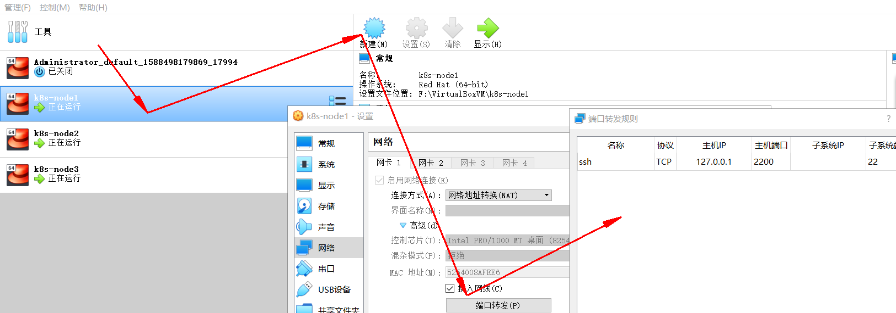

**解决方法：**

* 选择三个节点，然后执行“管理”->“全局设定”->“网络”，添加一个NAT网络。

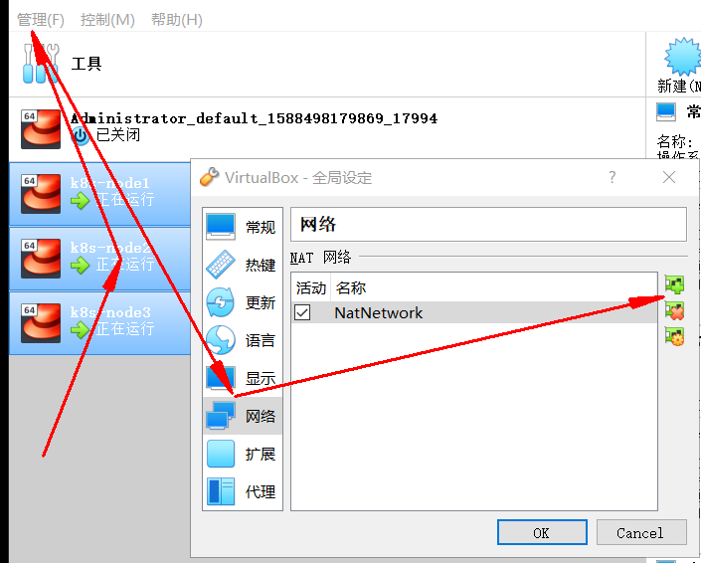

* 分别修改每台设备的网络类型，并刷新重新生成MAC地址。

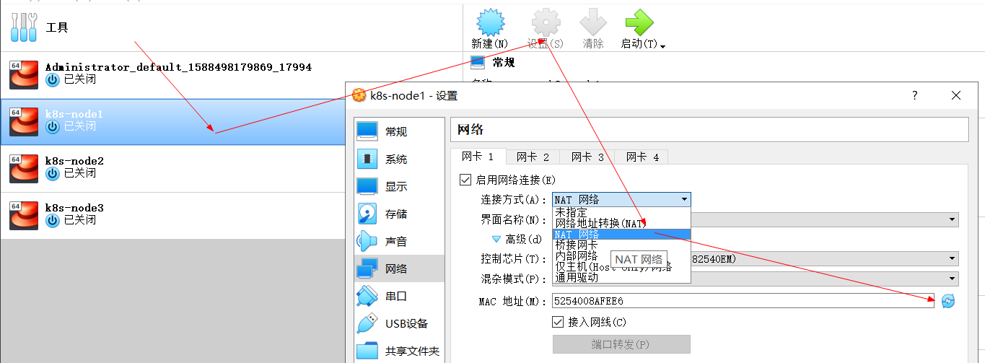

* 再次查看三个节点的IP

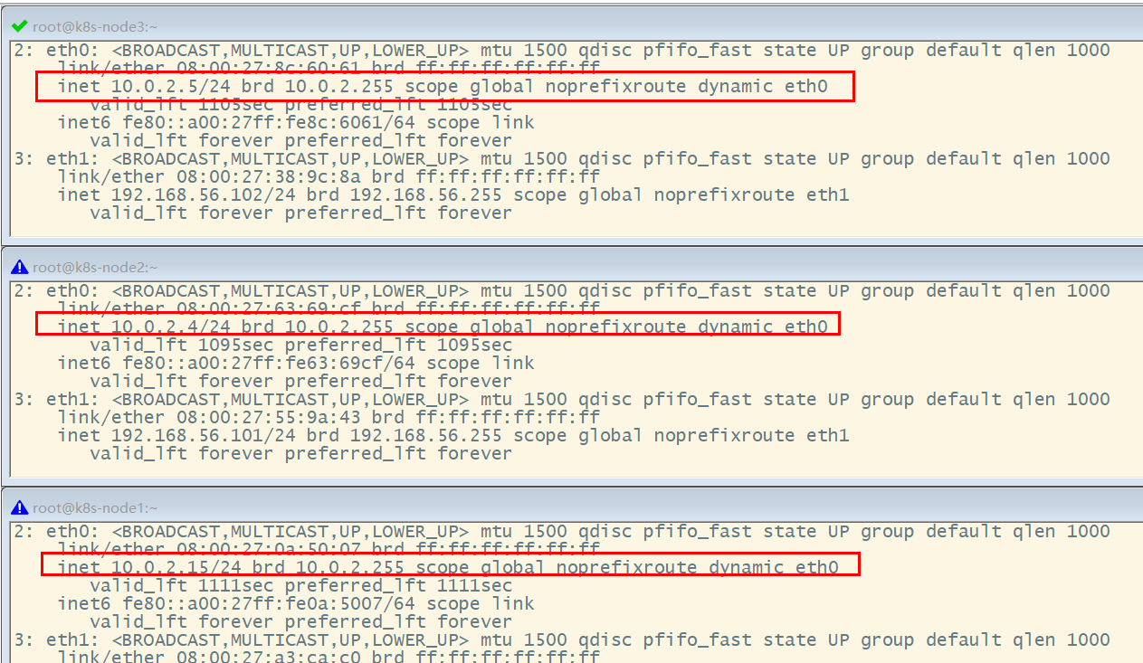

**（3）设置Linux环境（三个节点都执行）**

* 关闭防火墙

systemctl stop firewalld

systemctl disable firewalld

* 关闭Linux

sed -i 's/enforcing/disabled/' /etc/selinux/config

setenforce 0

* 关闭swap

swapoff -a #临时关闭

sed -ri 's/.*swap.*/#&/' /etc/fstab #永久关闭

free -g #验证，swap必须为0

* 添加主机名与IP对应关系：

查看主机名：

hostname

如果主机名不正确，可以通过“hostnamectl set-hostname <newhostname> :指定新的hostname”命令来进行修改。

vi /etc/hosts

10.0.2.15 k8s-node1

10.0.2.4 k8s-node2

10.0.2.5 k8s-node3

将桥接的IPV4流量传递到iptables的链：

cat > /etc/sysctl.d/k8s.conf <<EOF

net.bridge.bridge-nf-call-ip6tables = 1

net.bridge.bridge-nf-call-iptables = 1

EOF

应用规则：

sysctl --system

疑难问题：遇见提示是只读的文件系统，运行如下命令

mount -o remount rw /

* date 查看时间（可选）

yum -y install ntpupdate

ntpupdate time.window.com #同步最新时间

**5）所有节点安装docker、kubeadm、kubelet、kubectl**

Kubenetes默认CRI（容器运行时）为Docker，因此先安装Docker。

**（1）安装Docker**

1、卸载之前的docker

$ sudo yum remove docker \

docker-client \

docker-client-latest \

docker-common \

docker-latest \

docker-latest-logrotate \

docker-logrotate \

docker-engine

2、安装Docker -CE

$ sudo yum install -y yum-utils

$ sudo yum-config-manager \

--add-repo \

https://download.docker.com/linux/centos/docker-ce.repo

$ sudo yum -y install docker-ce docker-ce-cli containerd.io

3、配置镜像加速

sudo mkdir -p /etc/docker

sudo tee /etc/docker/daemon.json <<-'EOF'

{

"registry-mirrors": ["https://ke9h1pt4.mirror.aliyuncs.com"]

}

EOF

sudo systemctl daemon-reload

sudo systemctl restart docker

4、启动Docker && 设置docker开机启动

systemctl enable docker

* 1

基础环境准备好，可以给三个虚拟机备份一下；

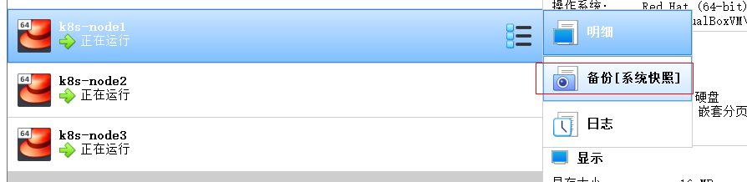

**（2）添加阿里与Yum源**

cat <<EOF > /etc/yum.repos.d/kubernetes.repo

[kubernetes]

name=Kubernetes

baseurl=https://mirrors.aliyun.com/kubernetes/yum/repos/kubernetes-el7-x86_64/

enabled=1

gpgcheck=1

repo_gpgcheck=1

gpgkey=https://mirrors.aliyun.com/kubernetes/yum/doc/yum-key.gpg https://mirrors.aliyun.com/kubernetes/yum/doc/rpm-package-key.gpg

EOF

更多详情见： https://developer.aliyun.com/mirror/kubernetes

**（3）安装kubeadm，kubelet和kubectl**

yum list|grep kube

安装

yum install -y kubelet-1.17.3 kubeadm-1.17.3 kubectl-1.17.3

开机启动

systemctl enable kubelet && systemctl start kubelet

查看kubelet的状态：

systemctl status kubelet

查看kubelet版本：

[root@k8s-node2 ~]# kubelet --version

Kubernetes v1.17.3

**6）部署k8s-master**

**（1）master节点初始化**

在Master节点上，创建并执行master_images.sh

#!/bin/bash

images=(

kube-apiserver:v1.17.3

kube-proxy:v1.17.3

kube-controller-manager:v1.17.3

kube-scheduler:v1.17.3

coredns:1.6.5

etcd:3.4.3-0

pause:3.1

)

for imageName in ${images[@]} ; do

docker pull registry.cn-hangzhou.aliyuncs.com/google_containers/$imageName

# docker tag registry.cn-hangzhou.aliyuncs.com/google_containers/$imageName k8s.gcr.io/$imageName

done

初始化kubeadm

$ kubeadm init \

--apiserver-advertise-address=10.0.2.15 \

--image-repository registry.cn-hangzhou.aliyuncs.com/google_containers \

--kubernetes-version v1.17.3 \

--service-cidr=10.96.0.0/16 \

--pod-network-cidr=10.244.0.0/16

* 1
* 2
* 3
* 4
* 5
* 6

注：

* –apiserver-advertise-address=10.0.2.21 ：这里的IP地址是master主机的地址，为上面的eth0网卡的地址；

执行结果：

[root@k8s-node1 opt]# kubeadm init \

> --apiserver-advertise-address=10.0.2.15 \

> --image-repository registry.cn-hangzhou.aliyuncs.com/google_containers \

> --kubernetes-version v1.17.3 \

> --service-cidr=10.96.0.0/16 \

> --pod-network-cidr=10.244.0.0/16

W0503 14:07:12.594252 10124 configset.go:202] WARNING: kubeadm cannot validate component configs for API groups [kubelet.config.k8s.io kubeproxy.config.k8s.io]

[init] Using Kubernetes version: v1.17.3

[preflight] Running pre-flight checks

[WARNING IsDockerSystemdCheck]: detected "cgroupfs" as the Docker cgroup driver. The recommended driver is "systemd". Please follow the guide at https://kubernetes.io/docs/setup/cri/

[preflight] Pulling images required for setting up a Kubernetes cluster

[preflight] This might take a minute or two, depending on the speed of your internet connection

[preflight] You can also perform this action in beforehand using 'kubeadm config images pull'

[kubelet-start] Writing kubelet environment file with flags to file "/var/lib/kubelet/kubeadm-flags.env"

[kubelet-start] Writing kubelet configuration to file "/var/lib/kubelet/config.yaml"

[kubelet-start] Starting the kubelet

[certs] Using certificateDir folder "/etc/kubernetes/pki"

[certs] Generating "ca" certificate and key

[certs] Generating "apiserver" certificate and key

[certs] apiserver serving cert is signed for DNS names [k8s-node1 kubernetes kubernetes.default kubernetes.default.svc kubernetes.default.svc.cluster.local] and IPs [10.96.0.1 10.0.2.15]

[certs] Generating "apiserver-kubelet-client" certificate and key

[certs] Generating "front-proxy-ca" certificate and key

[certs] Generating "front-proxy-client" certificate and key

[certs] Generating "etcd/ca" certificate and key

[certs] Generating "etcd/server" certificate and key

[certs] etcd/server serving cert is signed for DNS names [k8s-node1 localhost] and IPs [10.0.2.15 127.0.0.1 ::1]

[certs] Generating "etcd/peer" certificate and key

[certs] etcd/peer serving cert is signed for DNS names [k8s-node1 localhost] and IPs [10.0.2.15 127.0.0.1 ::1]

[certs] Generating "etcd/healthcheck-client" certificate and key

[certs] Generating "apiserver-etcd-client" certificate and key

[certs] Generating "sa" key and public key

[kubeconfig] Using kubeconfig folder "/etc/kubernetes"

[kubeconfig] Writing "admin.conf" kubeconfig file

[kubeconfig] Writing "kubelet.conf" kubeconfig file

[kubeconfig] Writing "controller-manager.conf" kubeconfig file

[kubeconfig] Writing "scheduler.conf" kubeconfig file

[control-plane] Using manifest folder "/etc/kubernetes/manifests"

[control-plane] Creating static Pod manifest for "kube-apiserver"

[control-plane] Creating static Pod manifest for "kube-controller-manager"

W0503 14:07:30.908642 10124 manifests.go:225] the default kube-apiserver authorization-mode is "Node,RBAC"; using "Node,RBAC"

[control-plane] Creating static Pod manifest for "kube-scheduler"

W0503 14:07:30.911330 10124 manifests.go:225] the default kube-apiserver authorization-mode is "Node,RBAC"; using "Node,RBAC"

[etcd] Creating static Pod manifest for local etcd in "/etc/kubernetes/manifests"

[wait-control-plane] Waiting for the kubelet to boot up the control plane as static Pods from directory "/etc/kubernetes/manifests". This can take up to 4m0s

[apiclient] All control plane components are healthy after 22.506521 seconds

[upload-config] Storing the configuration used in ConfigMap "kubeadm-config" in the "kube-system" Namespace

[kubelet] Creating a ConfigMap "kubelet-config-1.18" in namespace kube-system with the configuration for the kubelets in the cluster

[upload-certs] Skipping phase. Please see --upload-certs

[mark-control-plane] Marking the node k8s-node1 as control-plane by adding the label "node-role.kubernetes.io/master=''"

[mark-control-plane] Marking the node k8s-node1 as control-plane by adding the taints [node-role.kubernetes.io/master:NoSchedule]

[bootstrap-token] Using token: sg47f3.4asffoi6ijb8ljhq

[bootstrap-token] Configuring bootstrap tokens, cluster-info ConfigMap, RBAC Roles

[bootstrap-token] configured RBAC rules to allow Node Bootstrap tokens to get nodes

[bootstrap-token] configured RBAC rules to allow Node Bootstrap tokens to post CSRs in order for nodes to get long term certificate credentials

[bootstrap-token] configured RBAC rules to allow the csrapprover controller automatically approve CSRs from a Node Bootstrap Token

[bootstrap-token] configured RBAC rules to allow certificate rotation for all node client certificates in the cluster

[bootstrap-token] Creating the "cluster-info" ConfigMap in the "kube-public" namespace

[kubelet-finalize] Updating "/etc/kubernetes/kubelet.conf" to point to a rotatable kubelet client certificate and key

[addons] Applied essential addon: CoreDNS

[addons] Applied essential addon: kube-proxy

#表示kubernetes已经初始化成功了

Your Kubernetes control-plane has initialized successfully!

To start using your cluster, you need to run the following as a regular user:

mkdir -p $HOME/.kube

sudo cp -i /etc/kubernetes/admin.conf $HOME/.kube/config

sudo chown $(id -u):$(id -g) $HOME/.kube/config

You should now deploy a pod network to the cluster.

Run "kubectl apply -f [podnetwork].yaml" with one of the options listed at:

https://kubernetes.io/docs/concepts/cluster-administration/addons/

Then you can join any number of worker nodes by running the following on each as root:

kubeadm join 10.0.2.15:6443 --token sg47f3.4asffoi6ijb8ljhq \

--discovery-token-ca-cert-hash sha256:81fccdd29970cbc1b7dc7f171ac0234d53825bdf9b05428fc9e6767436991bfb

[root@k8s-node1 opt]#

由于默认拉取镜像地址k8s.cr.io国内无法访问，这里指定阿里云仓库地址。可以手动按照我们的images.sh先拉取镜像。

地址变为：registry.aliyuncs.com/googole_containers也可以。  
科普：无类别域间路由（Classless Inter-Domain Routing 、CIDR）是一个用于给用户分配IP地址以及在互联网上有效第路由IP数据包的对IP地址进行归类的方法。  
拉取可能失败，需要下载镜像。

运行完成提前复制：加入集群的令牌。

**（2）测试Kubectl（主节点执行）**

mkdir -p $HOME/.kube

sudo cp -i /etc/kubernetes/admin.conf $HOME/.kube/config

sudo chown $(id -u):$(id -g) $HOME/.kube/config

详细部署文档：https://kubernetes.io/docs/concepts/cluster-administration/addons/

$ kubectl get nodes #获取所有节点

目前Master状态为notready。等待网络加入完成即可。

$ journalctl -u kubelet #查看kubelet日志

kubeadm join 10.0.2.15:6443 --token sg47f3.4asffoi6ijb8ljhq \

--discovery-token-ca-cert-hash sha256:81fccdd29970cbc1b7dc7f171ac0234d53825bdf9b05428fc9e6767436991bfb

**7）安装POD网络插件（CNI）**

在master节点上执行按照POD网络插件

kubectl apply -f \

https://raw.githubusercontent.com/coreos/flanne/master/Documentation/kube-flannel.yml

以上地址可能被墙，可以直接获取本地已经下载的flannel.yml运行即可，如：

[root@k8s-node1 k8s]# kubectl apply -f kube-flannel.yml

podsecuritypolicy.policy/psp.flannel.unprivileged created

clusterrole.rbac.authorization.k8s.io/flannel created

clusterrolebinding.rbac.authorization.k8s.io/flannel created

serviceaccount/flannel created

configmap/kube-flannel-cfg created

daemonset.apps/kube-flannel-ds-amd64 created

daemonset.apps/kube-flannel-ds-arm64 created

daemonset.apps/kube-flannel-ds-arm created

daemonset.apps/kube-flannel-ds-ppc64le created

daemonset.apps/kube-flannel-ds-s390x created

[root@k8s-node1 k8s]#

同时flannel.yml中指定的images访问不到可以去docker hub找一个wget yml地址  
vi 修改yml 所有amd64的地址修改了即可  
等待大约3分钟  
kubectl get pods -n kube-system 查看指定名称空间的pods  
kubectl get pods -all-namespace 查看所有名称空间的pods

$ ip link set cni0 down 如果网络出现问题，关闭cni0，重启虚拟机继续测试  
执行watch kubectl get pod -n kube-system -o wide 监控pod进度  
等待3-10分钟，完全都是running以后继续

查看命名空间：

[root@k8s-node1 k8s]# kubectl get ns

NAME STATUS AGE

default Active 30m

kube-node-lease Active 30m

kube-public Active 30m

kube-system Active 30m

[root@k8s-node1 k8s]#

[root@k8s-node1 k8s]# kubectl get pods --all-namespaces

NAMESPACE NAME READY STATUS RESTARTS AGE

kube-system coredns-546565776c-9sbmk 0/1 Pending 0 31m

kube-system coredns-546565776c-t68mr 0/1 Pending 0 31m

kube-system etcd-k8s-node1 1/1 Running 0 31m

kube-system kube-apiserver-k8s-node1 1/1 Running 0 31m

kube-system kube-controller-manager-k8s-node1 1/1 Running 0 31m

kube-system kube-flannel-ds-amd64-6xwth 1/1 Running 0 2m50s

kube-system kube-proxy-sz2vz 1/1 Running 0 31m

kube-system kube-scheduler-k8s-node1 1/1 Running 0 31m

[root@k8s-node1 k8s]#

查看master上的节点信息：

[root@k8s-node1 k8s]# kubectl get nodes

NAME STATUS ROLES AGE VERSION

k8s-node1 Ready master 34m v1.17.3 #status为ready才能够执行下面的命令

[root@k8s-node1 k8s]#

最后再次执行，并且分别在“k8s-node2”和“k8s-node3”上也执行这里命令：

kubeadm join 10.0.2.15:6443 --token sg47f3.4asffoi6ijb8ljhq \

--discovery-token-ca-cert-hash sha256:81fccdd29970cbc1b7dc7f171ac0234d53825bdf9b05428fc9e6767436991bfb

[root@k8s-node1 opt]# kubectl get nodes;

NAME STATUS ROLES AGE VERSION

k8s-node1 Ready master 47m v1.17.3

k8s-node2 NotReady <none> 75s v1.17.3

k8s-node3 NotReady <none> 76s v1.17.3

[root@k8s-node1 opt]#

监控pod进度

watch kubectl get pod -n kube-system -o wide

等到所有的status都变为running状态后，再次查看节点信息：

[root@k8s-node1 ~]# kubectl get nodes;

NAME STATUS ROLES AGE VERSION

k8s-node1 Ready master 3h50m v1.17.3

k8s-node2 Ready <none> 3h3m v1.17.3

k8s-node3 Ready <none> 3h3m v1.17.3

[root@k8s-node1 ~]#

**8）加入kubenetes的Node节点**

在node节点中执行，向集群中添加新的节点，执行在kubeadm init 输出的kubeadm join命令；  
确保node节点成功：  
token过期怎么办  
kubeadm token create --print-join-command

**9）入门操作kubernetes集群**

1、在主节点上部署一个tomcat

kubectl create deployment tomcat6 --image=tomcat:6.0.53-jre8

获取所有的资源：

[root@k8s-node1 k8s]# kubectl get all

NAME READY STATUS RESTARTS AGE

pod/tomcat6-7b84fb5fdc-cfd8g 0/1 ContainerCreating 0 41s

NAME TYPE CLUSTER-IP EXTERNAL-IP PORT(S) AGE

service/kubernetes ClusterIP 10.96.0.1 <none> 443/TCP 70m

NAME READY UP-TO-DATE AVAILABLE AGE

deployment.apps/tomcat6 0/1 1 0 41s

NAME DESIRED CURRENT READY AGE

replicaset.apps/tomcat6-7b84fb5fdc 1 1 0 41s

[root@k8s-node1 k8s]#

kubectl get pods -o wide 可以获取到tomcat部署信息，能够看到它被部署到了k8s-node2上了

[root@k8s-node1 k8s]# kubectl get all -o wide

NAME READY STATUS RESTARTS AGE IP NODE NOMINATED NODE READINESS GATES

pod/tomcat6-7b84fb5fdc-cfd8g 1/1 Running 0 114s 10.244.2.2 k8s-node2 <none> <none>

NAME TYPE CLUSTER-IP EXTERNAL-IP PORT(S) AGE SELECTOR

service/kubernetes ClusterIP 10.96.0.1 <none> 443/TCP 71m <none>

NAME READY UP-TO-DATE AVAILABLE AGE CONTAINERS IMAGES SELECTOR

deployment.apps/tomcat6 1/1 1 1 114s tomcat tomcat:6.0.53-jre8 app=tomcat6

NAME DESIRED CURRENT READY AGE CONTAINERS IMAGES SELECTOR

replicaset.apps/tomcat6-7b84fb5fdc 1 1 1 114s tomcat tomcat:6.0.53-jre8 app=tomcat6,pod-template-hash=7b84fb5fdc

[root@k8s-node1 k8s]#

查看node2节点上，下载了哪些镜像：

[root@k8s-node2 opt]# docker images

REPOSITORY TAG IMAGE ID CREATED SIZE

registry.cn-hangzhou.aliyuncs.com/google_containers/kube-proxy v1.17.3 0d40868643c6 2 weeks ago 117MB

registry.cn-hangzhou.aliyuncs.com/google_containers/pause 3.2 80d28bedfe5d 2 months ago 683kB

quay.io/coreos/flannel v0.11.0-amd64 ff281650a721 15 months ago 52.6MB

tomcat 6.0.53-jre8 49ab0583115a 2 years ago 290MB

[root@k8s-node2 opt]#

查看Node2节点上，正在运行的容器：

[root@k8s-node2 opt]# docker ps

CONTAINER ID IMAGE COMMAND CREATED STATUS PORTS NAMES

9194cc4f0b7a tomcat "catalina.sh run" 2 minutes ago Up 2 minutes k8s_tomcat_tomcat6-7b84fb5fdc-cfd8g_default_0c9ebba2-992d-4c0e-99ef-3c4c3294bc59_0

f44af0c7c345 registry.cn-hangzhou.aliyuncs.com/google_containers/pause:3.2 "/pause" 3 minutes ago Up 3 minutes k8s_POD_tomcat6-7b84fb5fdc-cfd8g_default_0c9ebba2-992d-4c0e-99ef-3c4c3294bc59_0

ef74c90491e4 ff281650a721 "/opt/bin/flanneld -…" 20 minutes ago Up 20 minutes k8s_kube-flannel_kube-flannel-ds-amd64-5xs5j_kube-system_11a94346-316d-470b-9668-c15ce183abec_0

c8a524e5a193 registry.cn-hangzhou.aliyuncs.com/google_containers/kube-proxy "/usr/local/bin/kube…" 25 minutes ago Up 25 minutes k8s_kube-proxy_kube-proxy-mvlnk_kube-system_519de79a-e8d8-4b1c-a74e-94634cebabce_0

4590685c519a registry.cn-hangzhou.aliyuncs.com/google_containers/pause:3.2 "/pause" 26 minutes ago Up 26 minutes k8s_POD_kube-flannel-ds-amd64-5xs5j_kube-system_11a94346-316d-470b-9668-c15ce183abec_0

54e00af5cde4 registry.cn-hangzhou.aliyuncs.com/google_containers/pause:3.2 "/pause" 26 minutes ago Up 26 minutes k8s_POD_kube-proxy-mvlnk_kube-system_519de79a-e8d8-4b1c-a74e-94634cebabce_0

[root@k8s-node2 opt]#

在node1上执行：

[root@k8s-node1 k8s]# kubectl get pods

NAME READY STATUS RESTARTS AGE

tomcat6-7b84fb5fdc-cfd8g 1/1 Running 0 5m35s

[root@k8s-node1 k8s]# kubectl get pods --all-namespaces

NAMESPACE NAME READY STATUS RESTARTS AGE

default tomcat6-7b84fb5fdc-cfd8g 1/1 Running 0 163m

kube-system coredns-546565776c-9sbmk 1/1 Running 0 3h52m

kube-system coredns-546565776c-t68mr 1/1 Running 0 3h52m

kube-system etcd-k8s-node1 1/1 Running 0 3h52m

kube-system kube-apiserver-k8s-node1 1/1 Running 0 3h52m

kube-system kube-controller-manager-k8s-node1 1/1 Running 0 3h52m

kube-system kube-flannel-ds-amd64-5xs5j 1/1 Running 0 3h6m

kube-system kube-flannel-ds-amd64-6xwth 1/1 Running 0 3h24m

kube-system kube-flannel-ds-amd64-fvnvx 1/1 Running 0 3h6m

kube-system kube-proxy-7tkvl 1/1 Running 0 3h6m

kube-system kube-proxy-mvlnk 1/1 Running 0 3h6m

kube-system kube-proxy-sz2vz 1/1 Running 0 3h52m

kube-system kube-scheduler-k8s-node1 1/1 Running 0 3h52m

[root@k8s-node1 ~]#

从前面看到tomcat部署在Node2上，现在模拟因为各种原因宕机的情况，将node2关闭电源，观察情况。

[root@k8s-node1 ~]# kubectl get nodes

NAME STATUS ROLES AGE VERSION

k8s-node1 Ready master 4h4m v1.17.3

k8s-node2 NotReady <none> 3h18m v1.17.3

k8s-node3 Ready <none> 3h18m v1.17.3

[root@k8s-node1 ~]#

[root@k8s-node1 ~]# kubectl get pods -o wide

NAME READY STATUS RESTARTS AGE IP NODE NOMINATED NODE READINESS GATES

tomcat6-7b84fb5fdc-cfd8g 1/1 Running 0 177m 10.244.2.2 k8s-node2 <none> <none>

[root@k8s-node1 ~]#

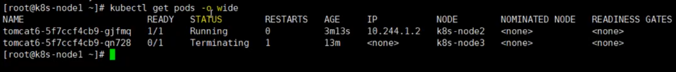

2、暴露nginx访问

在master上执行

kubectl expose deployment tomcat6 --port=80 --target-port=8080 --type=NodePort

pod的80映射容器的8080；server会带来pod的80

查看服务：

[root@k8s-node1 ~]# kubectl get svc

NAME TYPE CLUSTER-IP EXTERNAL-IP PORT(S) AGE

kubernetes ClusterIP 10.96.0.1 <none> 443/TCP 12h

tomcat6 NodePort 10.96.24.191 <none> 80:30526/TCP 49s

[root@k8s-node1 ~]#

[root@k8s-node1 ~]# kubectl get svc -o wide

NAME TYPE CLUSTER-IP EXTERNAL-IP PORT(S) AGE SELECTOR

kubernetes ClusterIP 10.96.0.1 <none> 443/TCP 12h <none>

tomcat6 NodePort 10.96.24.191 <none> 80:30526/TCP 3m30s app=tomcat6

[root@k8s-node1 ~]#

http://192.168.56.100:30526/

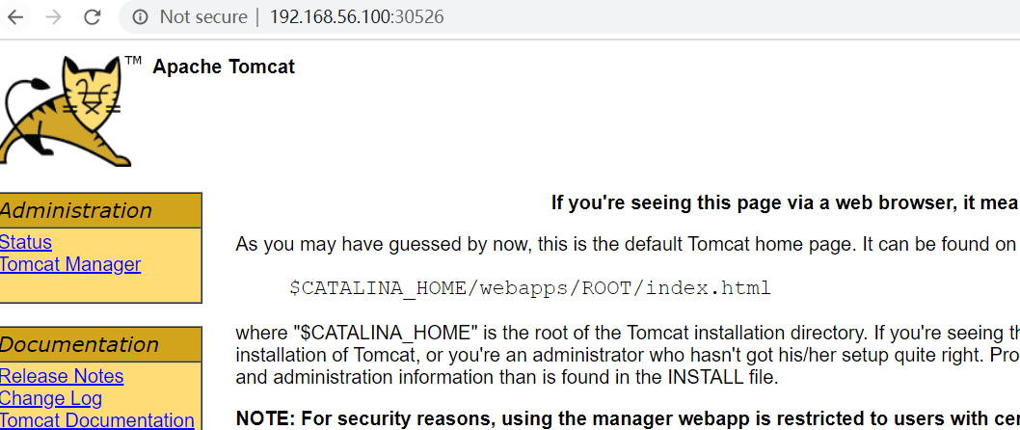

[root@k8s-node1 ~]# kubectl get all

NAME READY STATUS RESTARTS AGE

pod/tomcat6-7b84fb5fdc-qt5jm 1/1 Running 0 13m

NAME TYPE CLUSTER-IP EXTERNAL-IP PORT(S) AGE

service/kubernetes ClusterIP 10.96.0.1 <none> 443/TCP 12h

service/tomcat6 NodePort 10.96.24.191 <none> 80:30526/TCP 9m50s

NAME READY UP-TO-DATE AVAILABLE AGE

deployment.apps/tomcat6 1/1 1 1 11h

NAME DESIRED CURRENT READY AGE

replicaset.apps/tomcat6-7b84fb5fdc 1 1 1 11h

[root@k8s-node1 ~]#

3、动态扩容测试

kubectl get deployment

[root@k8s-node1 ~]# kubectl get deployment

NAME READY UP-TO-DATE AVAILABLE AGE

tomcat6 2/2 2 2 11h

[root@k8s-node1 ~]#

应用升级： kubectl set image (–help查看帮助)  
扩容：kubectl scale --replicas=3 deployment tomcat6

[root@k8s-node1 ~]# kubectl scale --replicas=3 deployment tomcat6

deployment.apps/tomcat6 scaled

[root@k8s-node1 ~]#

[root@k8s-node1 ~]# kubectl get pods -o wide

NAME READY STATUS RESTARTS AGE IP NODE NOMINATED NODE READINESS GATES

tomcat6-7b84fb5fdc-hdgmc 1/1 Running 0 61s 10.244.2.5 k8s-node2 <none> <none>

tomcat6-7b84fb5fdc-qt5jm 1/1 Running 0 19m 10.244.1.2 k8s-node3 <none> <none>

tomcat6-7b84fb5fdc-vlrh6 1/1 Running 0 61s 10.244.2.4 k8s-node2 <none> <none>

[root@k8s-node1 ~]# kubectl get svc -o wide

NAME TYPE CLUSTER-IP EXTERNAL-IP PORT(S) AGE SELECTOR

kubernetes ClusterIP 10.96.0.1 <none> 443/TCP 13h <none>

tomcat6 NodePort 10.96.24.191 <none> 80:30526/TCP 16m app=tomcat6

[root@k8s-node1 ~]#

扩容了多份，所有无论访问哪个node的指定端口，都可以访问到tomcat6

http://192.168.56.101:30526/

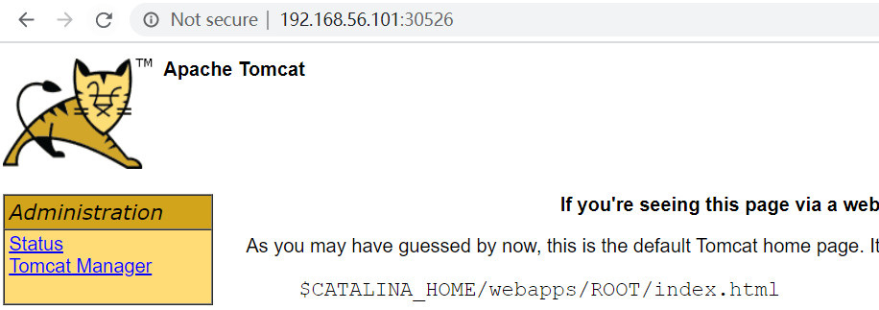

http://192.168.56.102:30526/

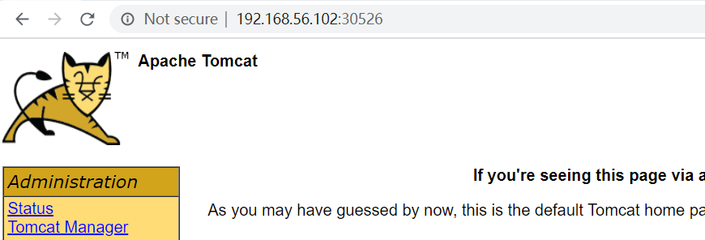

缩容：kubectl scale --replicas=2 deployment tomcat6

[root@k8s-node1 ~]# kubectl scale --replicas=2 deployment tomcat6

deployment.apps/tomcat6 scaled

[root@k8s-node1 ~]# kubectl get pods -o wide

NAME READY STATUS RESTARTS AGE IP NODE NOMINATED NODE READINESS GATES

tomcat6-7b84fb5fdc-hdgmc 0/1 Terminating 0 4m47s <none> k8s-node2 <none> <none>

tomcat6-7b84fb5fdc-qt5jm 1/1 Running 0 22m 10.244.1.2 k8s-node3 <none> <none>

tomcat6-7b84fb5fdc-vlrh6 1/1 Running 0 4m47s 10.244.2.4 k8s-node2 <none> <none>

[root@k8s-node1 ~]#

4、以上操作的yaml获取  
参照k8s细节

5、删除  
kubectl get all

#查看所有资源

[root@k8s-node1 ~]# kubectl get all

NAME READY STATUS RESTARTS AGE

pod/tomcat6-7b84fb5fdc-qt5jm 1/1 Running 0 26m

pod/tomcat6-7b84fb5fdc-vlrh6 1/1 Running 0 8m16s

NAME TYPE CLUSTER-IP EXTERNAL-IP PORT(S) AGE

service/kubernetes ClusterIP 10.96.0.1 <none> 443/TCP 13h

service/tomcat6 NodePort 10.96.24.191 <none> 80:30526/TCP 22m

NAME READY UP-TO-DATE AVAILABLE AGE

deployment.apps/tomcat6 2/2 2 2 11h

NAME DESIRED CURRENT READY AGE

replicaset.apps/tomcat6-7b84fb5fdc 2 2 2 11h

[root@k8s-node1 ~]#

#删除deployment.apps/tomcat6

[root@k8s-node1 ~]# kubectl delete deployment.apps/tomcat6

deployment.apps "tomcat6" deleted

#查看剩余的资源

[root@k8s-node1 ~]# kubectl get all

NAME TYPE CLUSTER-IP EXTERNAL-IP PORT(S) AGE

service/kubernetes ClusterIP 10.96.0.1 <none> 443/TCP 13h

service/tomcat6 NodePort 10.96.24.191 <none> 80:30526/TCP 30m

[root@k8s-node1 ~]#

[root@k8s-node1 ~]#

#删除service/tomcat6

[root@k8s-node1 ~]# kubectl delete service/tomcat6

service "tomcat6" deleted

[root@k8s-node1 ~]# kubectl get all

NAME TYPE CLUSTER-IP EXTERNAL-IP PORT(S) AGE

service/kubernetes ClusterIP 10.96.0.1 <none> 443/TCP 13h

[root@k8s-node1 ~]#

kubectl delete deploye/nginx  
kubectl delete service/nginx-service

**3、K8s细节**

**1、kubectl文档**

​ https://kubernetes.io/zh/docs/reference/kubectl/overview/

**2、资源类型**

https://kubernetes.io/zh/docs/reference/kubectl/overview/#%e8%b5%84%e6%ba%90%e7%b1%bb%e5%9e%8b

**3、格式化输出**

https://kubernetes.io/zh/docs/reference/kubectl/overview/

所有 kubectl 命令的默认输出格式都是人类可读的纯文本格式。要以特定格式向终端窗口输出详细信息，可以将 -o 或 --output 参数添加到受支持的 kubectl 命令中。

**语法**

kubectl [command] [TYPE] [NAME] -o=<output_format>

根据 kubectl 操作，支持以下输出格式：

| **Output format** | **Description** |
| --- | --- |
| -o custom-columns= | 使用逗号分隔的[自定义列](https://kubernetes.io/zh/docs/reference/kubectl/overview/" \l "custom-columns)列表打印表。 |
| -o custom-columns-file= | 使用 `` 文件中的[自定义列](https://kubernetes.io/zh/docs/reference/kubectl/overview/#custom-columns)模板打印表。 |
| -o json | 输出 JSON 格式的 API 对象 |
| `-o jsonpath= | 打印 [jsonpath](https://kubernetes.io/docs/reference/kubectl/jsonpath/) 表达式定义的字段 |
| -o jsonpath-file= | 打印 `` 文件中 [jsonpath](https://kubernetes.io/docs/reference/kubectl/jsonpath/) 表达式定义的字段。 |
| -o name | 仅打印资源名称而不打印任何其他内容。 |
| -o wide | 以纯文本格式输出，包含任何附加信息。对于 pod 包含节点名。 |
| -o yaml | 输出 YAML 格式的 API 对象。 |

**示例**

在此示例中，以下命令将单个 pod 的详细信息输出为 YAML 格式的对象：

kubectl get pod web-pod-13je7 -o yaml

请记住：有关每个命令支持哪种输出格式的详细信息，请参阅 [kubectl](https://kubernetes.io/docs/user-guide/kubectl/) 参考文档。

–dry-run：

–dry-run=‘none’: Must be “none”, “server”, or “client”. If client strategy, only print the object that would be

sent, without sending it. If server strategy, submit server-side request without persisting the resource.

值必须为none，server或client。如果是客户端策略，则只打印该发送对象，但不发送它。如果服务器策略，提交服务器端请求而不持久化资源。

也就是说，通过–dry-run选项，并不会真正的执行这条命令。

[root@k8s-node1 ~]# kubectl create deployment tomcat6 --image=tomcat:6.0.53-jre8 --dry-run -o yaml

W0504 03:39:08.389369 8107 helpers.go:535] --dry-run is deprecated and can be replaced with --dry-run=client.

apiVersion: apps/v1

kind: Deployment

metadata:

creationTimestamp: null

labels:

app: tomcat6

name: tomcat6

spec:

replicas: 1

selector:

matchLabels:

app: tomcat6

strategy: {}

template:

metadata:

creationTimestamp: null

labels:

app: tomcat6

spec:

containers:

- image: tomcat:6.0.53-jre8

name: tomcat

resources: {}

status: {}

[root@k8s-node1 ~]#

实际上我们也可以将这个yaml输出到文件，然后使用kubectl apply -f来应用它

#输出到tomcat6.yaml

[root@k8s-node1 ~]# kubectl create deployment tomcat6 --image=tomcat:6.0.53-jre8 --dry-run -o yaml >tomcat6.yaml

W0504 03:46:18.180366 11151 helpers.go:535] --dry-run is deprecated and can be replaced with --dry-run=client.

#修改副本数为3

[root@k8s-node1 ~]# cat tomcat6.yaml

apiVersion: apps/v1

kind: Deployment

metadata:

creationTimestamp: null

labels:

app: tomcat6

name: tomcat6

spec:

replicas: 3 #修改副本数为3

selector:

matchLabels:

app: tomcat6

strategy: {}

template:

metadata:

creationTimestamp: null

labels:

app: tomcat6

spec:

containers:

- image: tomcat:6.0.53-jre8

name: tomcat

resources: {}

status: {}

#应用tomcat6.yaml

[root@k8s-node1 ~]# kubectl apply -f tomcat6.yaml

deployment.apps/tomcat6 created

[root@k8s-node1 ~]#

查看pods：

[root@k8s-node1 ~]# kubectl get pods

NAME READY STATUS RESTARTS AGE

tomcat6-7b84fb5fdc-5jh6t 1/1 Running 0 8s

tomcat6-7b84fb5fdc-8lhwv 1/1 Running 0 8s

tomcat6-7b84fb5fdc-j4qmh 1/1 Running 0 8s

[root@k8s-node1 ~]#

查看某个pod的具体信息：

[root@k8s-node1 ~]# kubectl get pods tomcat6-7b84fb5fdc-5jh6t -o yaml

apiVersion: v1

kind: Pod

metadata:

creationTimestamp: "2020-05-04T03:50:47Z"

generateName: tomcat6-7b84fb5fdc-

labels:

app: tomcat6

pod-template-hash: 7b84fb5fdc

managedFields:

- apiVersion: v1

fieldsType: FieldsV1

fieldsV1:

f:metadata:

f:generateName: {}

f:labels:

.: {}

f:app: {}

f:pod-template-hash: {}

f:ownerReferences:

.: {}

k:{"uid":"292bfe3b-dd63-442e-95ce-c796ab5bdcc1"}:

.: {}

f:apiVersion: {}

f:blockOwnerDeletion: {}

f:controller: {}

f:kind: {}

f:name: {}

f:uid: {}

f:spec:

f:containers:

k:{"name":"tomcat"}:

.: {}

f:image: {}

f:imagePullPolicy: {}

f:name: {}

f:resources: {}

f:terminationMessagePath: {}

f:terminationMessagePolicy: {}

f:dnsPolicy: {}

f:enableServiceLinks: {}

f:restartPolicy: {}

f:schedulerName: {}

f:securityContext: {}

f:terminationGracePeriodSeconds: {}

manager: kube-controller-manager

operation: Update

time: "2020-05-04T03:50:47Z"

- apiVersion: v1

fieldsType: FieldsV1

fieldsV1:

f:status:

f:conditions:

k:{"type":"ContainersReady"}:

.: {}

f:lastProbeTime: {}

f:lastTransitionTime: {}

f:status: {}

f:type: {}

k:{"type":"Initialized"}:

.: {}

f:lastProbeTime: {}

f:lastTransitionTime: {}

f:status: {}

f:type: {}

k:{"type":"Ready"}:

.: {}

f:lastProbeTime: {}

f:lastTransitionTime: {}

f:status: {}

f:type: {}

f:containerStatuses: {}

f:hostIP: {}

f:phase: {}

f:podIP: {}

f:podIPs:

.: {}

k:{"ip":"10.244.2.7"}:

.: {}

f:ip: {}

f:startTime: {}

manager: kubelet

operation: Update

time: "2020-05-04T03:50:49Z"

name: tomcat6-7b84fb5fdc-5jh6t

namespace: default

ownerReferences:

- apiVersion: apps/v1

blockOwnerDeletion: true

controller: true

kind: ReplicaSet

name: tomcat6-7b84fb5fdc

uid: 292bfe3b-dd63-442e-95ce-c796ab5bdcc1

resourceVersion: "46229"

selfLink: /api/v1/namespaces/default/pods/tomcat6-7b84fb5fdc-5jh6t

uid: 2f661212-3b03-47e4-bcb8-79782d5c7578

spec:

containers:

- image: tomcat:6.0.53-jre8

imagePullPolicy: IfNotPresent

name: tomcat

resources: {}

terminationMessagePath: /dev/termination-log

terminationMessagePolicy: File

volumeMounts:

- mountPath: /var/run/secrets/kubernetes.io/serviceaccount

name: default-token-bxqtw

readOnly: true

dnsPolicy: ClusterFirst

enableServiceLinks: true

nodeName: k8s-node2

priority: 0

restartPolicy: Always

schedulerName: default-scheduler

securityContext: {}

serviceAccount: default

serviceAccountName: default

terminationGracePeriodSeconds: 30

tolerations:

- effect: NoExecute

key: node.kubernetes.io/not-ready

operator: Exists

tolerationSeconds: 300

- effect: NoExecute

key: node.kubernetes.io/unreachable

operator: Exists

tolerationSeconds: 300

volumes:

- name: default-token-bxqtw

secret:

defaultMode: 420

secretName: default-token-bxqtw

status:

conditions:

- lastProbeTime: null

lastTransitionTime: "2020-05-04T03:50:47Z"

status: "True"

type: Initialized

- lastProbeTime: null

lastTransitionTime: "2020-05-04T03:50:49Z"

status: "True"

type: Ready

- lastProbeTime: null

lastTransitionTime: "2020-05-04T03:50:49Z"

status: "True"

type: ContainersReady

- lastProbeTime: null

lastTransitionTime: "2020-05-04T03:50:47Z"

status: "True"

type: PodScheduled

containerStatuses:

- containerID: docker://18eb0798384ea44ff68712cda9be94b6fb96265206c554a15cee28c288879304

image: tomcat:6.0.53-jre8

imageID: docker-pullable://tomcat@sha256:8c643303012290f89c6f6852fa133b7c36ea6fbb8eb8b8c9588a432beb24dc5d

lastState: {}

name: tomcat

ready: true

restartCount: 0

started: true

state:

running:

startedAt: "2020-05-04T03:50:49Z"

hostIP: 10.0.2.4

phase: Running

podIP: 10.244.2.7

podIPs:

- ip: 10.244.2.7

qosClass: BestEffort

startTime: "2020-05-04T03:50:47Z"

**命令参考**

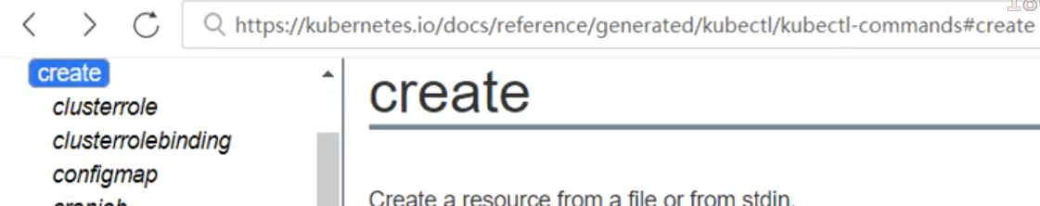

**service的意义**

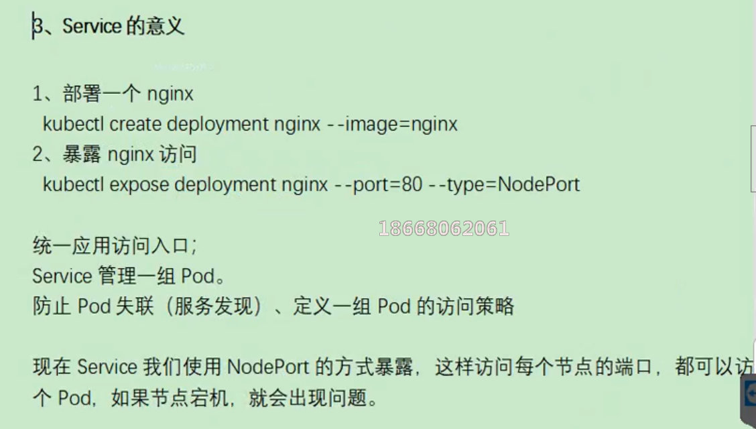

前面我们通过命令行的方式，部署和暴露了tomcat，实际上也可以通过yaml的方式来完成这些操作。

#这些操作实际上是为了获取Deployment的yaml模板

[root@k8s-node1 ~]# kubectl create deployment tomcat6 --image=tomcat:6.0.53-jre8 --dry-run -o yaml >tomcat6-deployment.yaml

W0504 04:13:28.265432 24263 helpers.go:535] --dry-run is deprecated and can be replaced with --dry-run=client.

[root@k8s-node1 ~]# ls tomcat6-deployment.yaml

tomcat6-deployment.yaml

[root@k8s-node1 ~]#

修改“tomcat6-deployment.yaml”内容如下：

apiVersion: apps/v1

kind: Deployment

metadata:

labels:

app: tomcat6

name: tomcat6

spec:

replicas: 3

selector:

matchLabels:

app: tomcat6

template:

metadata:

labels:

app: tomcat6

spec:

containers:

- image: tomcat:6.0.53-jre8

name: tomcat

#部署

[root@k8s-node1 ~]# kubectl apply -f tomcat6-deployment.yaml

deployment.apps/tomcat6 configured

#查看资源

[root@k8s-node1 ~]# kubectl get all

NAME READY STATUS RESTARTS AGE

pod/tomcat6-7b84fb5fdc-5jh6t 1/1 Running 0 27m

pod/tomcat6-7b84fb5fdc-8lhwv 1/1 Running 0 27m

pod/tomcat6-7b84fb5fdc-j4qmh 1/1 Running 0 27m

NAME TYPE CLUSTER-IP EXTERNAL-IP PORT(S) AGE

service/kubernetes ClusterIP 10.96.0.1 <none> 443/TCP 14h

NAME READY UP-TO-DATE AVAILABLE AGE

deployment.apps/tomcat6 3/3 3 3 27m

NAME DESIRED CURRENT READY AGE

replicaset.apps/tomcat6-7b84fb5fdc 3 3 3 27m

[root@k8s-node1 ~]#

kubectl expose deployment tomcat6 --port=80 --target-port=8080 --type=NodePort --dry-run -o yaml

apiVersion: v1

kind: Service

metadata:

creationTimestamp: null

labels:

app: tomcat6

name: tomcat6

spec:

ports:

- port: 80

protocol: TCP

targetPort: 8080

selector:

app: tomcat6

type: NodePort

status:

loadBalancer: {}

将这段输出和“tomcat6-deployment.yaml”进行拼接，表示部署完毕并进行暴露服务：

apiVersion: apps/v1

kind: Deployment

metadata:

labels:

app: tomcat6

name: tomcat6

spec:

replicas: 3

selector:

matchLabels:

app: tomcat6

template:

metadata:

labels:

app: tomcat6

spec:

containers:

- image: tomcat:6.0.53-jre8

name: tomcat

---

apiVersion: v1

kind: Service

metadata:

creationTimestamp: null

labels:

app: tomcat6

name: tomcat6

spec:

ports:

- port: 80

protocol: TCP

targetPort: 8080

selector:

app: tomcat6

type: NodePort

部署并暴露服务

[root@k8s-node1 ~]# kubectl apply -f tomcat6-deployment.yaml

deployment.apps/tomcat6 created

service/tomcat6 created

查看服务和部署信息

[root@k8s-node1 ~]# kubectl get all

NAME READY STATUS RESTARTS AGE

pod/tomcat6-7b84fb5fdc-dsqmb 1/1 Running 0 4s

pod/tomcat6-7b84fb5fdc-gbmxc 1/1 Running 0 5s

pod/tomcat6-7b84fb5fdc-kjlc6 1/1 Running 0 4s

NAME TYPE CLUSTER-IP EXTERNAL-IP PORT(S) AGE

service/kubernetes ClusterIP 10.96.0.1 <none> 443/TCP 14h

service/tomcat6 NodePort 10.96.147.210 <none> 80:30172/TCP 4s

NAME READY UP-TO-DATE AVAILABLE AGE

deployment.apps/tomcat6 3/3 3 3 5s

NAME DESIRED CURRENT READY AGE

replicaset.apps/tomcat6-7b84fb5fdc 3 3 3 5s

[root@k8s-node1 ~]#

访问node1，node1和node3的30172端口：

[root@k8s-node1 ~]# curl -I http://192.168.56.{100,101,102}:30172/

HTTP/1.1 200 OK

Server: Apache-Coyote/1.1

Accept-Ranges: bytes

ETag: W/"7454-1491118183000"

Last-Modified: Sun, 02 Apr 2017 07:29:43 GMT

Content-Type: text/html

Content-Length: 7454

Date: Mon, 04 May 2020 04:35:35 GMT

HTTP/1.1 200 OK

Server: Apache-Coyote/1.1

Accept-Ranges: bytes

ETag: W/"7454-1491118183000"

Last-Modified: Sun, 02 Apr 2017 07:29:43 GMT

Content-Type: text/html

Content-Length: 7454

Date: Mon, 04 May 2020 04:35:35 GMT

HTTP/1.1 200 OK

Server: Apache-Coyote/1.1

Accept-Ranges: bytes

ETag: W/"7454-1491118183000"

Last-Modified: Sun, 02 Apr 2017 07:29:43 GMT

Content-Type: text/html

Content-Length: 7454

Date: Mon, 04 May 2020 04:35:35 GMT

[root@k8s-node1 ~]#

**Ingress**

通过Ingress发现pod进行关联。基于域名访问  
通过Ingress controller实现POD负载均衡  
支持TCP/UDP 4层负载均衡和HTTP 7层负载均衡

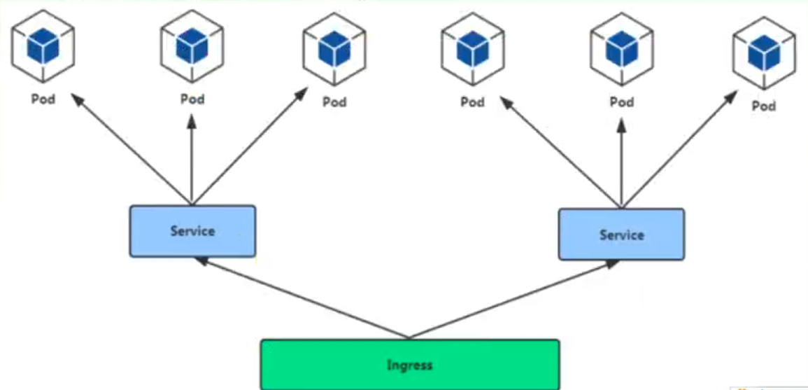

步骤：  
（1）部署Ingress controller

执行“k8s/ingress-controller.yaml”

[root@k8s-node1 k8s]# kubectl apply -f ingress-controller.yaml

namespace/ingress-nginx created

configmap/nginx-configuration created

configmap/tcp-services created

configmap/udp-services created

serviceaccount/nginx-ingress-serviceaccount created

clusterrole.rbac.authorization.k8s.io/nginx-ingress-clusterrole created

role.rbac.authorization.k8s.io/nginx-ingress-role created

rolebinding.rbac.authorization.k8s.io/nginx-ingress-role-nisa-binding created

clusterrolebinding.rbac.authorization.k8s.io/nginx-ingress-clusterrole-nisa-binding created

daemonset.apps/nginx-ingress-controller created

service/ingress-nginx created

[root@k8s-node1 k8s]#

查看

[root@k8s-node1 k8s]# kubectl get pods --all-namespaces

NAMESPACE NAME READY STATUS RESTARTS AGE

default tomcat6-7b84fb5fdc-dsqmb 1/1 Running 0 16m

default tomcat6-7b84fb5fdc-gbmxc 1/1 Running 0 16m

default tomcat6-7b84fb5fdc-kjlc6 1/1 Running 0 16m

ingress-nginx nginx-ingress-controller-9q6cs 0/1 ContainerCreating 0 40s

ingress-nginx nginx-ingress-controller-qx572 0/1 ContainerCreating 0 40s

kube-system coredns-546565776c-9sbmk 1/1 Running 1 14h

kube-system coredns-546565776c-t68mr 1/1 Running 1 14h

kube-system etcd-k8s-node1 1/1 Running 1 14h

kube-system kube-apiserver-k8s-node1 1/1 Running 1 14h

kube-system kube-controller-manager-k8s-node1 1/1 Running 1 14h

kube-system kube-flannel-ds-amd64-5xs5j 1/1 Running 2 13h

kube-system kube-flannel-ds-amd64-6xwth 1/1 Running 2 14h

kube-system kube-flannel-ds-amd64-fvnvx 1/1 Running 1 13h

kube-system kube-proxy-7tkvl 1/1 Running 1 13h

kube-system kube-proxy-mvlnk 1/1 Running 2 13h

kube-system kube-proxy-sz2vz 1/1 Running 1 14h

kube-system kube-scheduler-k8s-node1 1/1 Running 1 14h

[root@k8s-node1 k8s]#

这里master节点负责调度，具体执行交给node2和node3来完成，能够看到它们正在下载镜像

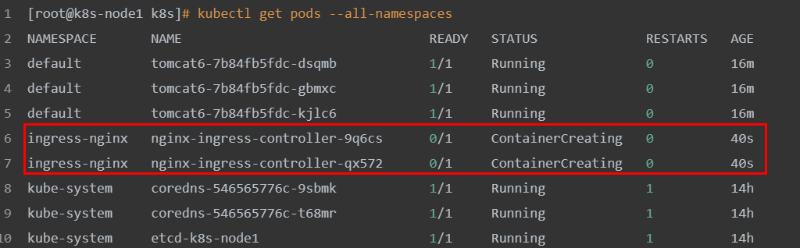

（2）创建Ingress规则

apiVersion: extensions/v1beta1

kind: Ingress

metadata:

name: web

spec:

rules:

- host: tomcat6.kubenetes.com

http:

paths:

- backend:

serviceName: tomcat6

servicePort: 80

[root@k8s-node1 k8s]# touch ingress-tomcat6.yaml

#将上面的规则，添加到ingress-tomcat6.yaml文件中

[root@k8s-node1 k8s]# vi ingress-tomcat6.yaml

[root@k8s-node1 k8s]# kubectl apply -f ingress-tomcat6.yaml

ingress.extensions/web created

[root@k8s-node1 k8s]#

修改本机的hosts文件，添加如下的域名转换规则：

192.168.56.102 tomcat6.kubenetes.com

测试: http://tomcat6.kubenetes.com/

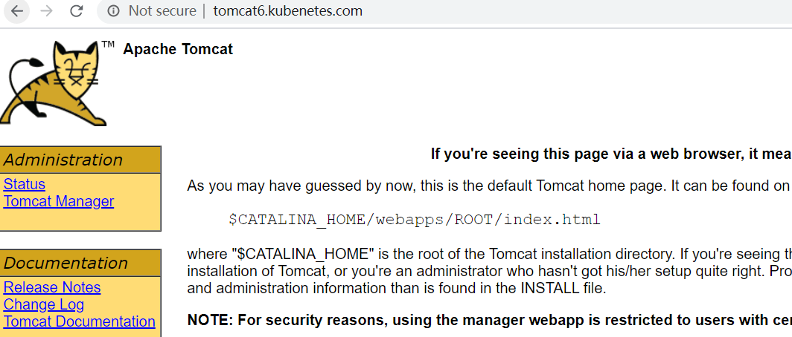

并且集群中即便有一个节点不可用，也不影响整体的运行。

**安装kubernetes可视化界面——DashBoard**

1、部署DashBoard

$ kubectl appy -f kubernetes-dashboard.yaml

文件在“k8s”源码目录提供

2、暴露DashBoard为公共访问

默认DashBoard只能集群内部访问，修改Service为NodePort类型，暴露到外部

kind: Service

apiVersion: v1

metadata:

labels:

k8s-app: kubernetes-dashboard

name: kubernetes-dashboard

namespace: kube-system

spec:

type: NodePort

ports:

- port: 443

targetPort: 8443

nodePort: 3001

selector:

k8s-app: kubernetes-dashboard

访问地址：http://NodeIP:30001

3、创建授权账号

$ kubectl create serviceaccount dashboar-admin -n kube-sysem

$ kubectl create clusterrolebinding dashboar-admin --clusterrole=cluter-admin --serviceaccount=kube-system:dashboard-admin

$ kubectl describe secrets -n kube-system $( kubectl -n kube-system get secret |awk '/dashboard-admin/{print $1}' )

使用输出的token登录dashboard

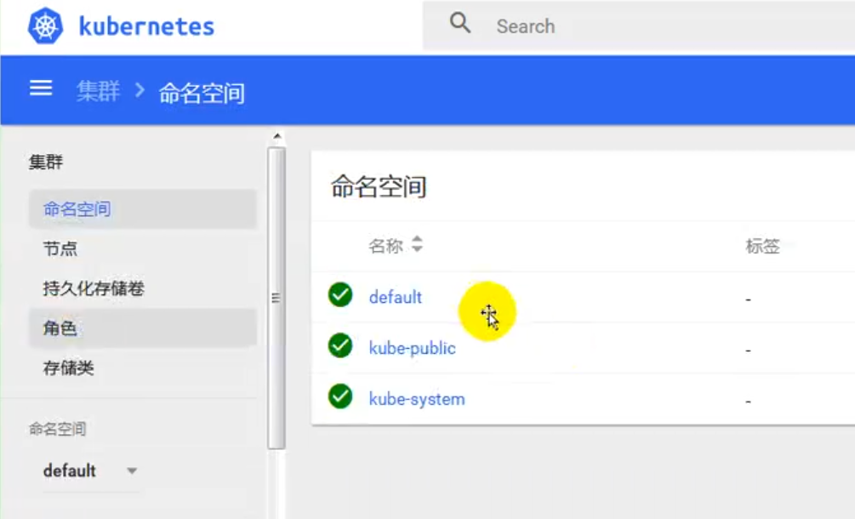

**kubesphere**

默认的dashboard没啥用，我们用kubesphere可以打通全部的devops链路，kubesphere集成了很多套件，集群要求比较高  
https://kubesphere.io

kuboard也很不错，集群要求不高  
https://kuboard.cn/support/

**1、简洁**

kubesphere是一款面向云原声设计的开源项目，在目前主流容器调度平台kubernets智商构建的分布式多用户容器管理平台，提供简单易用的操作界面以及向导式操作方式，在降低用户使用容器调度平台学习成本的同时，极大降低开发、测试、运维的日常工作的复杂度。

**2、安装前提提交**

**1、安装helm（master节点执行）**

helm是kubernetes的包管理器。包管理器类似于在Ubuntu中使用的apt，centos中的yum或者python中的pip一样，能够快速查找，下载和安装软件包。Helm有客户端组件helm和服务端组件Tiller组成，能够将一组K8S资源打包统一管理，是查找、共享和使用为Kubernetes构建的软件的最佳方式。

1）安装

curl -L https://git.io/get_helm.sh|bash

由于被墙的原因，使用我们给定的get_helm.sh。

[root@k8s-node1 k8s]# ll

total 68

-rw-r--r-- 1 root root 7149 Feb 27 01:58 get_helm.sh

-rw-r--r-- 1 root root 6310 Feb 28 05:16 ingress-controller.yaml

-rw-r--r-- 1 root root 209 Feb 28 13:18 ingress-demo.yml

-rw-r--r-- 1 root root 236 May 4 05:09 ingress-tomcat6.yaml

-rwxr--r-- 1 root root 15016 Feb 26 15:05 kube-flannel.yml

-rw-r--r-- 1 root root 4737 Feb 26 15:38 kubernetes-dashboard.yaml

-rw-r--r-- 1 root root 3841 Feb 27 01:09 kubesphere-complete-setup.yaml

-rw-r--r-- 1 root root 392 Feb 28 11:33 master_images.sh

-rw-r--r-- 1 root root 283 Feb 28 11:34 node_images.sh

-rw-r--r-- 1 root root 1053 Feb 28 03:53 product.yaml

-rw-r--r-- 1 root root 931 May 3 10:08 Vagrantfile

[root@k8s-node1 k8s]# sh get_helm.sh

Downloading https://get.helm.sh/helm-v2.16.6-linux-amd64.tar.gz

Preparing to install helm and tiller into /usr/local/bin

helm installed into /usr/local/bin/helm

tiller installed into /usr/local/bin/tiller

Run 'helm init' to configure helm.

[root@k8s-node1 k8s]#

2）验证版本

helm version

3）创建权限（master执行）

创建helm-rbac.yaml，写入如下内容

apiVersion: v1

kind: ServiceAccount

metadata:

name: tiller

namespace: kube-system

---

apiVersion: rbac.authorization.k8s.io/v1

kind: ClusterRoleBinding

metadata:

name: tiller

roleRef:

apiGroup: rbac.authorization.k8s.io

kind: ClusterRole

name: cluster-admin

subjects:

- kind: ServiceAccount

name: kubernetes-dashboard

namespace: kube-system

应用配置：

[root@k8s-node1 k8s]# kubectl apply -f helm-rbac.yaml

serviceaccount/tiller created

clusterrolebinding.rbac.authorization.k8s.io/tiller created

[root@k8s-node1 k8s]#

**2、安装Tilller（Master执行）**

1、初始化

[root@k8s-node1 k8s]# helm init --service-account=tiller --tiller-image=sapcc/tiller:v2.16.3 --history-max 300

Creating /root/.helm

Creating /root/.helm/repository

Creating /root/.helm/repository/cache

Creating /root/.helm/repository/local

Creating /root/.helm/plugins

Creating /root/.helm/starters

Creating /root/.helm/cache/archive

Creating /root/.helm/repository/repositories.yaml

Adding stable repo with URL: https://kubernetes-charts.storage.googleapis.com

Adding local repo with URL: http://127.0.0.1:8879/charts

$HELM_HOME has been configured at /root/.helm.

Tiller (the Helm server-side component) has been installed into your Kubernetes Cluster.

Please note: by default, Tiller is deployed with an insecure 'allow unauthenticated users' policy.

To prevent this, run `helm init` with the --tiller-tls-verify flag.

For more information on securing your installation see: https://v2.helm.sh/docs/securing_installation/

[root@k8s-node1 k8s]#

–tiller-image 指定镜像，否则会被墙，等待节点上部署的tiller完成即可。

[root@k8s-node1 k8s]# kubectl get pods -n kube-system

NAME READY STATUS RESTARTS AGE

coredns-546565776c-9sbmk 1/1 Running 3 23h

coredns-546565776c-t68mr 1/1 Running 3 23h

etcd-k8s-node1 1/1 Running 3 23h

kube-apiserver-k8s-node1 1/1 Running 3 23h

kube-controller-manager-k8s-node1 1/1 Running 3 23h

kube-flannel-ds-amd64-5xs5j 1/1 Running 4 22h

kube-flannel-ds-amd64-6xwth 1/1 Running 5 23h

kube-flannel-ds-amd64-fvnvx 1/1 Running 4 22h

kube-proxy-7tkvl 1/1 Running 3 22h

kube-proxy-mvlnk 1/1 Running 4 22h

kube-proxy-sz2vz 1/1 Running 3 23h

kube-scheduler-k8s-node1 1/1 Running 3 23h

kubernetes-dashboard-975499656-jxczv 0/1 ImagePullBackOff 0 7h45m

tiller-deploy-8cc566858-67bxb 1/1 Running 0 31s

[root@k8s-node1 k8s]#

查看集群的所有节点信息：

kubectl get node -o wide

[root@k8s-node1 k8s]# kubectl get node -o wide

NAME STATUS ROLES AGE VERSION INTERNAL-IP EXTERNAL-IP OS-IMAGE KERNEL-VERSION CONTAINER-RUNTIME

k8s-node1 Ready master 23h v1.17.3 10.0.2.15 <none> CentOS Linux 7 (Core) 3.10.0-957.12.2.el7.x86_64 docker://19.3.8

k8s-node2 Ready <none> 22h v1.17.3 10.0.2.4 <none> CentOS Linux 7 (Core) 3.10.0-957.12.2.el7.x86_64 docker://19.3.8

k8s-node3 Ready <none> 22h v1.17.3 10.0.2.5 <none> CentOS Linux 7 (Core) 3.10.0-957.12.2.el7.x86_64 docker://19.3.8

[root@k8s-node1 k8s]#

2、测试

helm install stable/nginx-ingress --name nginx-ingress

最小化安装 KubeSphere

若集群可用 CPU > 1 Core 且可用内存 > 2 G，可以使用以下命令最小化安装 KubeSphere：

kubectl apply -f https://raw.githubusercontent.com/kubesphere/ks-installer/master/kubesphere-minimal.yaml

**提示：若您的服务器提示无法访问 GitHub，可将** [kubesphere-minimal.yaml](https://github.com/kubesphere/ks-installer/blob/master/kubesphere-minimal.yaml) **或** [kubesphere-complete-setup.yaml](https://github.com/kubesphere/ks-installer/blob/master/kubesphere-complete-setup.yaml) **文件保存到本地作为本地的静态文件，再参考上述命令进行安装。**

1. 查看滚动刷新的安装日志，请耐心等待安装成功。

$ kubectl logs -n kubesphere-system $(kubectl get pod -n kubesphere-system -l app=ks-install -o jsonpath='{.items[0].metadata.name}') -f

说明：安装过程中若遇到问题，也可以通过以上日志命令来排查问题。